APPENDIX B

**CONFERENCE PRESENTATION**

Our paper on **Hybrid application based skin lesion analyzer using deep neural networks** was presented at ICIOT 2020 conference held at SRM. 200+ shortlisted teams presented theirpapers on various fields in the conference. Our paper got accepted as paper id : 25 with a plagiarism of just 2 %.

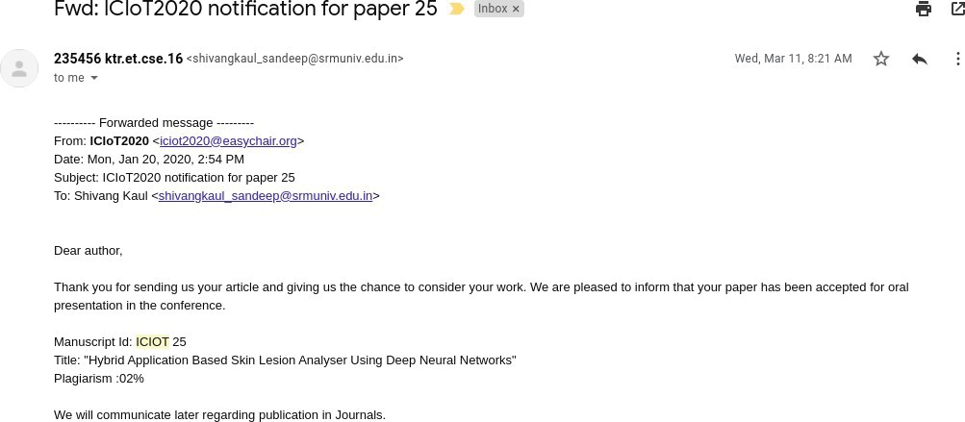

# Figure A.1: ICIOT 2020 Acceptance

On presenting the paper in this international conference held at SRM KTR campus, we received positive remarks and suggestion from the judging panel. We were then awarded the best paper award at the same conference.

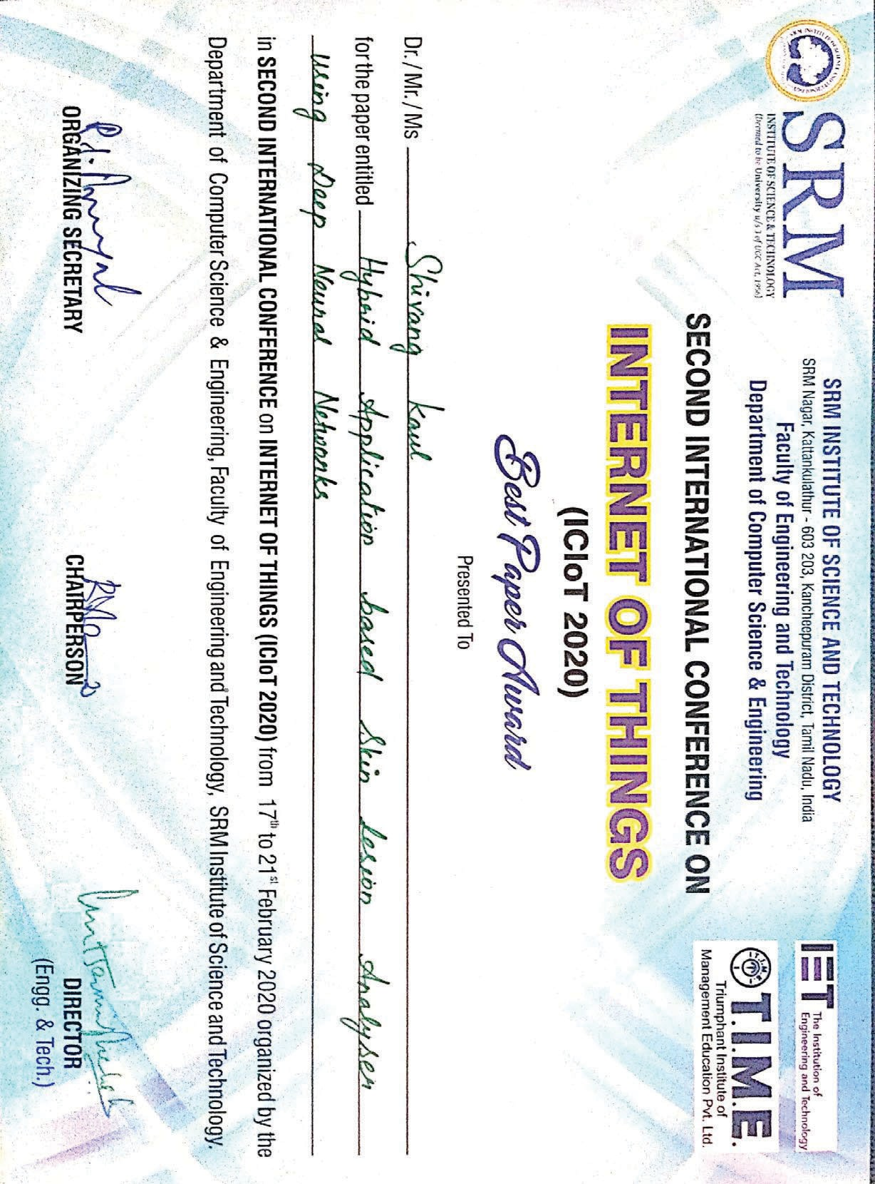

# Figure A.2: ICIOT 2020 Best Paper award

83